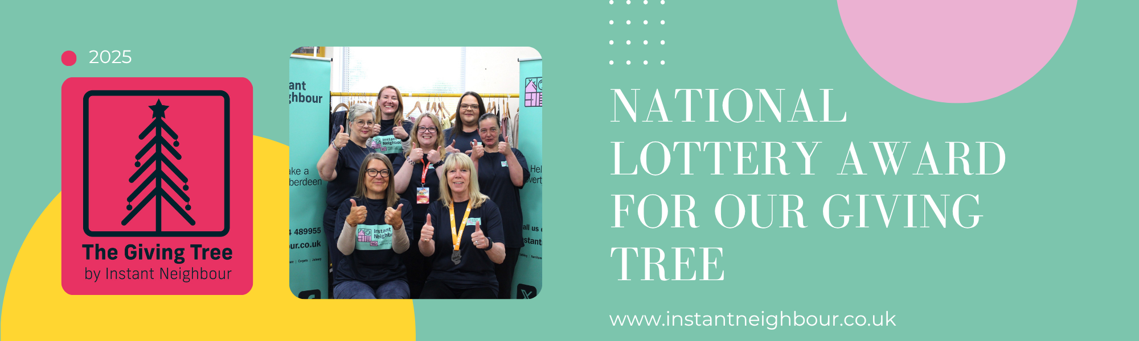
Nov, 2025
National Lottery ‘Awards for All’ Grants £17,500 to Our Giving Tree!
We are thrilled and incredibly proud to announce that our application to The National Lottery ‘Awards for All’ has been successful!
Thanks to National Lottery players, we have been awarded a fantastic £17,500 grant over two years to support our beloved Christmas Giving Tree Appeal. This is a monumental moment for our project and will allow us to create an even bigger wave of festive joy across our city.
What This Means for Our Giving Tree
This generous funding is a game-changer. It means that for the next two Christmases, we can:
Reach More People: Ensure that every tag on our trees is fulfilled, guaranteeing a gift for every child and young person on our list.
Grow Our Impact: Expand our appeal to partner with more local organisations, helping us identify and support those in need who we might have missed before.
Strengthen Our Project: Cover essential costs like gift wrapping and transportation, making our initiative more sustainable and efficient than ever.
We are so excited to put this funding to work and make the festive season brighter for everyone in our community.
A Heartfelt Thank You
We want to extend a massive thank you to every single National Lottery player. It’s because of you that grants like this are possible, and your support directly translates into festive magic for your neighbours.
We also want to thank our incredible team of volunteers and every person who has ever taken a tag from our tree. Your generosity is the heart of this appeal, and with this new funding, we can build on the wonderful foundation you've helped us create.
About Our Christmas Giving Tree Appeal
For those who are new to our community, the Christmas Giving Tree is our annual initiative to ensure no child is forgotten during the holidays. Here’s how you can be part of it:
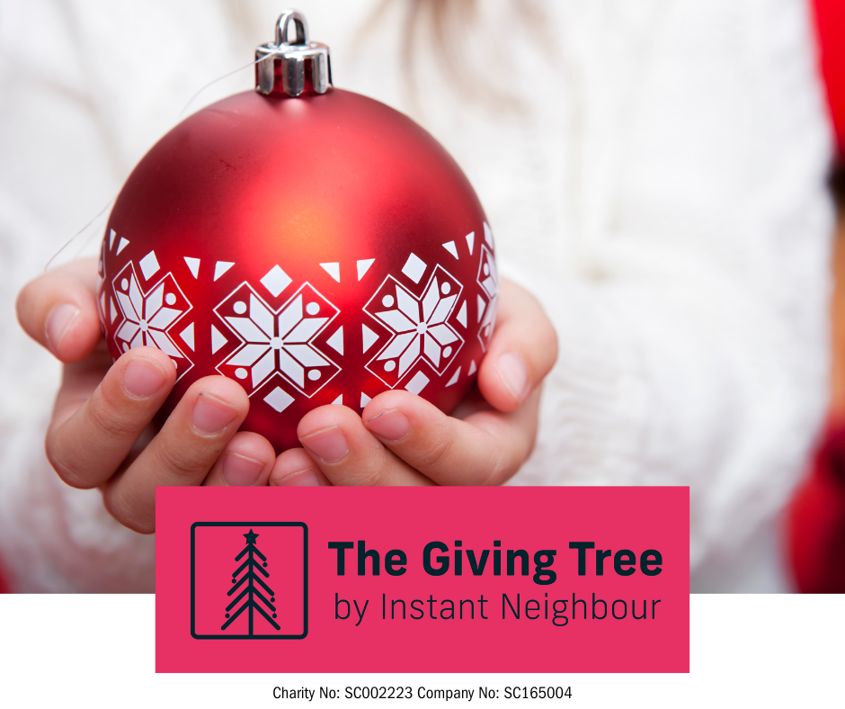 | 1. Find Our Trees: Before Christmas, you’ll see our Giving Trees pop up in local libraries, supermarkets, and community centres.  2. Take a Tag: Each tag on the tree has the age, and gender of our young person.  3. Be a Secret Santa: Purchase the gift and return it (unwrapped) to the drop-off point.  4. We Do the Rest: Our volunteers will collect, wrap, and distribute all the presents discreetly to individuals and families through our local partner networks.
Stay tuned for more updates as we prepare for our most impactful Christmas yet!
Together, we are making a real difference.

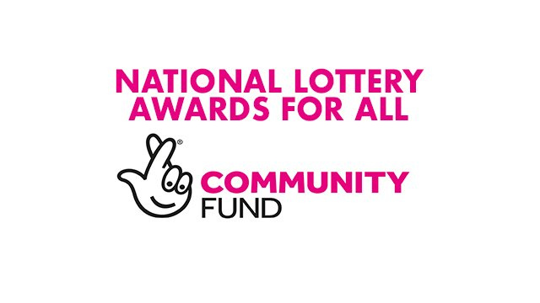

 | The Giving Tree | Instant Neighbour

